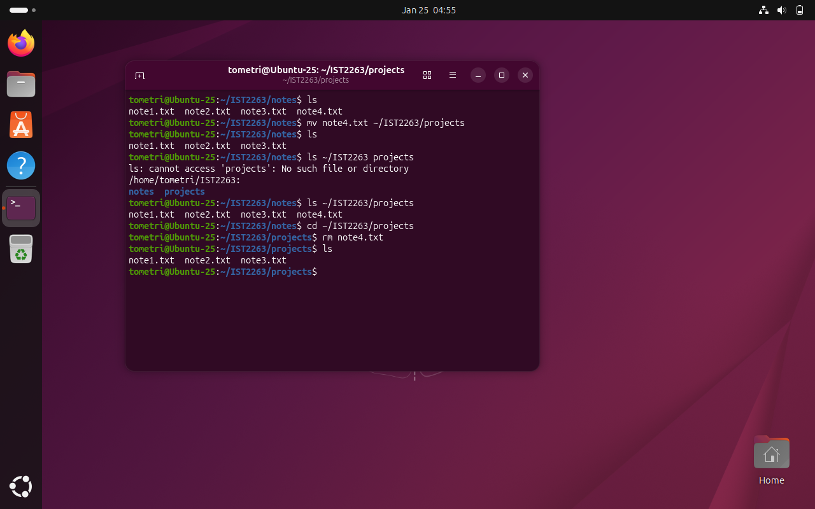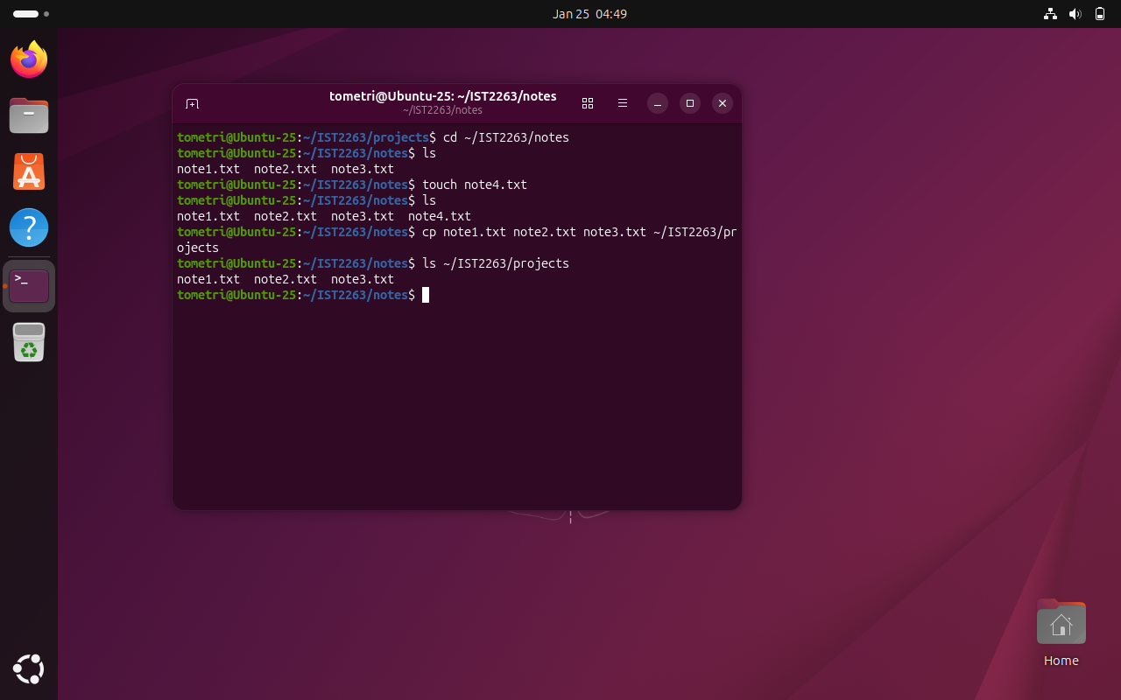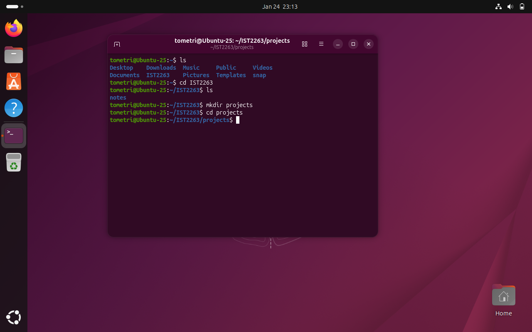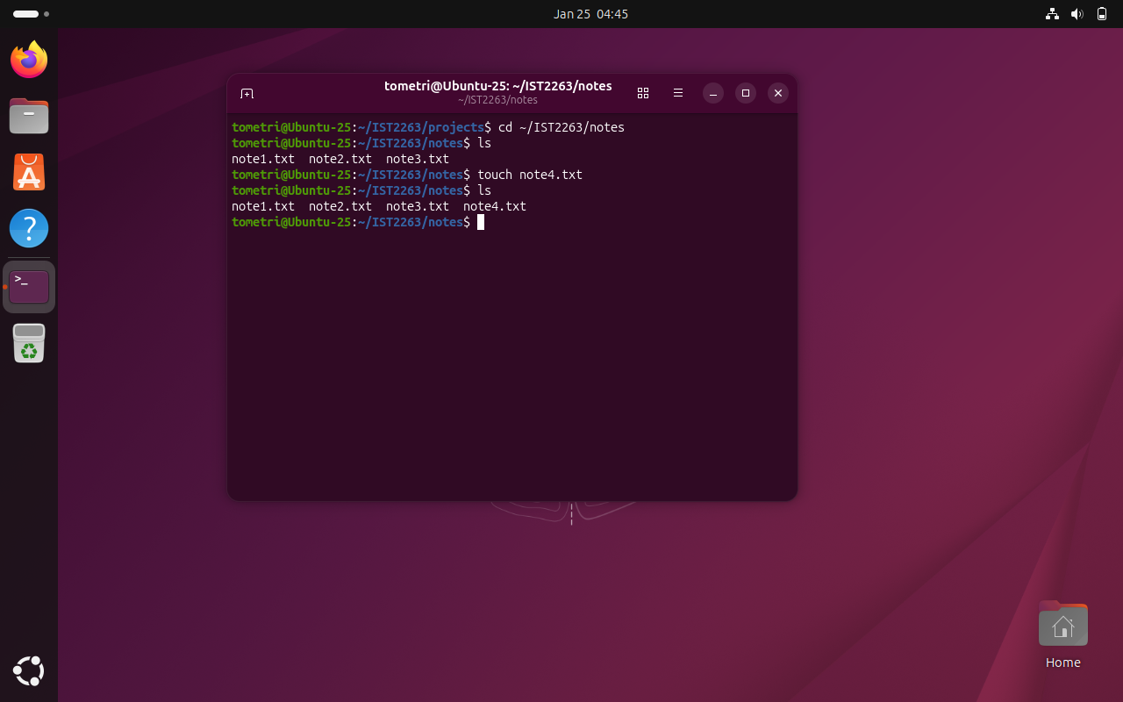
- These screenshots display the notes and projects directories in the IST2263 directory. The usage of touch, cp, mv, ls, cd, mkdir, and rm commands to create four files, copy them from notes to projects, move one file from notes to projects, and remove one file from projects.

- The home directory is just as stated, a ‘home’ directory. /etc has the global config files for the system, and /var/log has the system logs.

- Touch, cp, mv, rm, ls, mkdir

- I forgot the / at one point and the command didn’t execute correctly.

